CreateJS In Brief

Over the past several months, I've been making games and animations with a Javascript library called CreateJS. The library contains series of four components to assist with developing for HTML5; one for graphics (via the <canvas> https://developer.mozilla.org/en-US/docs/HTML/Canvas element), one for tweening values, one for sound (using <audio> https://developer.mozilla.org/en-US/docs/Web/HTML/Element/audio, webAudio https://dvcs.w3.org/hg/audio/raw-file/tip/webaudio/specification.html, or flash), and one for preloading. This article introduce the graphics component, EaselJS, as it is the most interesting – and the easiest to misuse. A basic working knowledge of HTML5 is required for this article.

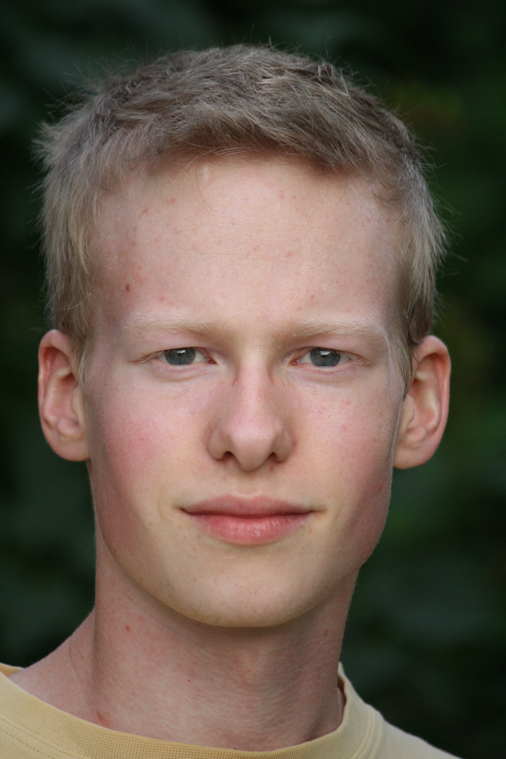
About the author: David Roberts is a developer currently living in Vancouver, British Columbia. In his spare time, he works on a beautiful open-source platformer game called Frogatto and Friends. You can download it at http://www.frogatto.com, or you can steal his recent 3D puzzle game from http://cubetrains.com.

Layers
When we start a project, it is natural to make the scene by adding different objects to the stage, in order of back to front. This stands up fairly well, provided we only want to add objects in front of everything. In the following example, a cloud scuds past our actor.

Listing 1. A single cloud.
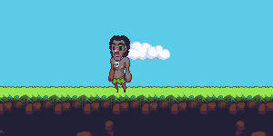
<HTML>
<head>
<title>Example 1-0: Clouds</title>
<script src="http://code.createjs.com/createjs-2013.05.14.min.js"></script>
</head>
<body>
<canvas id="output" width=300 height=150></canvas>
<script>
"use strict"

//Create a new "stage", from the createjs library, to put our images in.
var stage = new createjs.Stage("output");

//We'll add some scenery to the stage, then add an actor.
addLand(stage);
addCloud(stage, 0, 40);
addActor(stage, 99, 38);

//CreateJS comes with a "Ticker" object which fires each frame. We'll make it so that we repaint the stage each time it's called, via our stage's "update" function.
createjs.Ticker.addEventListener("tick", function paintStage() {
stage.update(); });

function addLand(stage) {
var land = new createjs.Bitmap("images/land.png");
stage.addChild(land); //The background image includes the blue sky.
}

function addCloud(stage, x, y) {
var cloud = new createjs.Bitmap("images/cloud.png");
cloud.x = x, cloud.y = y;
stage.addChild(cloud);

//We'll move the cloud behind the player because it looks good.
createjs.Ticker.addEventListener("tick", function moveCloud() {
cloud.x += 2;
});
}

function addActor(stage, x, y) {
//All the images in this scene have been drawn from the Open Pixel Platformer. See http://www.pixeljoint.com/forum/forum_topics.asp?FID=23 for more details.
var actor = new createjs.Bitmap("images/male native.png");
actor.x = x, actor.y = y;
stage.addChild(actor);
}
</script>
</body>
</HTML>

Here, we've created a stage, added some objects to it, and set it to continually redraw itself to reflect the changing position of the cloud. Looking at the output, however, that one cloud seems awful lonely. We'll add in a little timer to give him some friends. Add the following code around at line 22 of the script.

Listing 2. Adding more clouds.
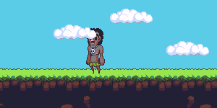
//We'll add in another cloud, at a random height, every 2 seconds.
window.setInterval(function addClouds() {
addCloud(stage, 0, Math.random()*60);
}, 2000);

Now we have more clouds, but they're going in front of our character. To fix this, we'll create several containers. A container is holds other objects, like a stage does. If when we add our clouds to a container behind our actor, the container will keep them behind our actor where they belong. Replace the calls to addLand , addCloud , and addActor, starting on line 14, with the listing 3:

Listing 3. Properly layered clouds.
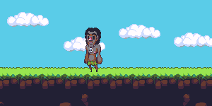
//First, we'll add some containers to keep our scenery organized.
var backgroundContainer, sceneryContainer, actorContainer;
stage.addChild(backgroundContainer = new createjs.Container());
stage.addChild(sceneryContainer = new createjs.Container());
stage.addChild(actorContainer = new createjs.Container());

//We'll add some scenery to the stage, then add an actor.
addLand(backgroundContainer);
addCloud(sceneryContainer, 0, 40);
addActor(actorContainer, 99, 38);

//We'll add in another cloud, at a random height, every 2 seconds.
window.setInterval(function addClouds() {
addCloud(sceneryContainer, 0, Math.random()*60);
}, 2000);

This is how you implement z-layers in EaselJS, although it doesn't seem to be explicitly stated in the documentation.

This is quite a nice approach to z-layers. First, it is quite scalable. Because we have named layers, we can easily add more layers between them and move around existing layers. Second, our layer orders are now defined in one place. This means that when we need to rearrange them – and we will if we're working on a large project – we won't have to go hunting for a hundred different constants in our files. Lastly, we can apply almost any effect to a container that we can also apply to an object. For example, if we had our background in a separate container, we could easily add parallax scrolling just by moving the container.

Supplementary Listing 4. The final product.
<HTML>
<head>
<title>Example 1-2: Clouds</title>
<script src="http://code.createjs.com/createjs-2013.05.14.min.js"></script>
</head>
<body>
<canvas id="output" width=300 height=150></canvas>
<script>
"use strict"

//Create a new "stage", from the createjs library, to put our images in.
var stage = new createjs.Stage("output");

//First, we'll add some containers to keep our scenery organized.
var backgroundContainer, sceneryContainer, actorContainer;
stage.addChild(backgroundContainer = new createjs.Container());
stage.addChild(sceneryContainer = new createjs.Container());
stage.addChild(actorContainer = new createjs.Container());

//We'll add some scenery to the stage, then add an actor.
addLand(backgroundContainer);
addCloud(sceneryContainer, 0, 40);
addActor(actorContainer, 99, 38);

//We'll add in another cloud, at a random height, every 2 seconds.
window.setInterval(function addClouds() {
addCloud(sceneryContainer, 0, Math.random()*60);
}, 2000);

//CreateJS comes with a "Ticker" object which fires each frame. We'll make it so that we repaint the stage each time it's called, via our stage's "update" function.
createjs.Ticker.addEventListener("tick", function paintStage() {
stage.update(); });

function addLand(stage) {
var land = new createjs.Bitmap("images/land.png");
stage.addChild(land); //The background image includes the blue sky.
}

function addCloud(stage, x, y) {
var cloud = new createjs.Bitmap("images/cloud.png");
cloud.x = x, cloud.y = y;
stage.addChild(cloud);

//We'll move the cloud behind the player because it looks good.
createjs.Ticker.addEventListener("tick", function moveCloud() {
cloud.x += 2;
});
}

function addActor(stage, x, y) {
//All the images in this scene have been drawn from the Open Pixel Platformer. See http://www.pixeljoint.com/forum/forum_topics.asp?FID=23 for more details.
var actor = new createjs.Bitmap("images/male native.png");
actor.x = x, actor.y = y;
stage.addChild(actor);
}
</script>
</body>
</HTML>

Performance
In a large game of minesweeper (such as http://mienfield.com), we can have a few thousand tiles on the screen at once. A simple, direct implementation will happily use up all our available processing power in CreateJS, though.

Listing 5. A hard-to-compute version of a Minesweeper field.
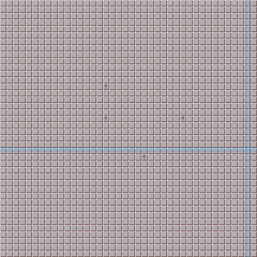
<HTML>
<head>
<title>Example 2-0: Minesweeper</title>
<script src="http://code.createjs.com/createjs-2013.05.14.min.js"></script>
</head>
<body>
<canvas id="output" width=320 height=320></canvas>
<script>
"use strict"

var stage = new createjs.Stage("output");

//Set up some z-layers, as in example 1.
var tileContainer, uiContainer;
stage.addChild(tileContainer = new createjs.Container());
stage.addChild(uiContainer = new createjs.Container());

//Add 1600 tiles in a square. This should load one of our processors a little, and we can observe it with our task manager. You can open one up in Chrome by pressing shift-esc.
var tiles = [];
for (var x = 0; x < 40; x++) {
tiles.push([])
for (var y = 0; y < 40; y++) {
tiles[x][y] = addTile(tileContainer, x, y);
};
};
//When we click on the tile, we should make it respond. We'll use the question mark in place of an actual game of minesweeper.
stage.addEventListener("mousedown", function revealTile(event) {
var x = Math.floor(event.stageX/8); //StageX is the pixel of the stage we clicked on.
var y = Math.floor(event.stageY/8); //8 is how wide our tiles are.
tiles[x][y].image.src="images/question mark tile.png";
});

//Add two blue bars to the stage to track the mouse.
var horizontalBlueBar = addGridTool(uiContainer, -90);
var verticalBlueBar = addGridTool(uiContainer, 0);
//We'll make them track our mouse cursor. How quickly they do so will also give us a good feel for our framerate.
stage.addEventListener("stagemousemove", function updateGridTool(event) {
horizontalBlueBar.y = event.stageY;
verticalBlueBar.x = event.stageX;
});

//When we redraw the stage, we should make the blue bars flicker a bit for effect.
createjs.Ticker.addEventListener("tick", function paintStage() {
horizontalBlueBar.alpha = 0.3 + Math.random()/3;
verticalBlueBar.alpha = 0.3 + Math.random()/3;

stage.update();
});

function addTile(stage, x, y) {
var tile = new createjs.Bitmap("images/blank tile.png");
tile.x = x*8, tile.y = y*8; //Our tile is 16 pixels wide, but we'll scale them down for this example.
tile.scaleX = 0.5, tile.scaleY = 0.5; //We need to draw lots of objects to produce a measurable stress on a modern computer.
stage.addChild(tile);
return tile;
}

function addGridTool(stage, rotation) {
var gridTool = new createjs.Bitmap("images/bar gradient.png");
gridTool.regX = 4; //Offset the bar a bit in the narrow dimension, so our mouse will be over the middle of it.
gridTool.scaleY = 320; //Make the bar as long as the gamefield.
gridTool.rotation = rotation;
stage.addChild(gridTool)
return gridTool;
}
</script>
</body>
</HTML>

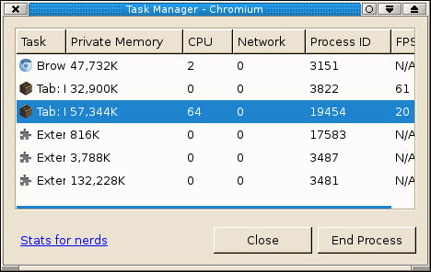
On my computer, this version takes over half of the processing power of the page to run. (To open this task list, you can press shift-esc in Chrome https://www.google.com/intl/en/chrome/browser/ or Chromium http://www.chromium.org/.)

Why does this version use so much processing power? It turns out that CreateJS does not implement the “dirty rect” optimization (http://c2.com/cgi/wiki?DirtyRectangles) when it redraws the scene. This is because it is prohibitive to calculate the bounding box for some of the elements the library can draw, such as vector graphics and text. http://blog.createjs.com/width-height-in-easeljs/ explains the trouble in more detail – it's quite an interesting problem. For our purposes, this means that each time we call stage.update() the backing canvas is cleared and every single object on the stage has to be drawn again. All 1600 of them. To fix this, we'll cache() our background to a new canvas and call updateCache() when we need to refresh the tiles.

Listing 6. Optimized tile drawing.
//Set up some z-layers, as in example 1.
var tileContainer, uiContainer;
stage.addChild(tileContainer = new createjs.Container());
stage.addChild(uiContainer = new createjs.Container());

tileContainer.cache(0,0,320,320);

//Add 1600 tiles in a square. This should load one of our processors a little, and we can observe it with our task manager. You can open one up in Chrome by pressing shift-esc.
var tiles = [];
for (var x = 0; x < 40; x++) {
tiles.push([])
for (var y = 0; y < 40; y++) {
tiles[x][y] = addTile(tileContainer, x, y);
};
};
tiles[39][39].image.onload = function() {tileContainer.updateCache()}; //When the last tile's image has loaded, we need to refresh the cache. Otherwise, we'll just draw a blank canvas.
//When we click on the tile, we should make it respond. We'll use the question mark in place of an actual game of minesweeper.
stage.addEventListener("mousedown", function revealTile(event) {
var x = Math.floor(event.stageX/8); //StageX is the pixel of the stage we clicked on. (The formula gives us the index of our tile.)
var y = Math.floor(event.stageY/8); //8 is how wide our tiles are.
tiles[x][y].image.src="images/question mark tile.png";
tiles[x][y].image.onload = function() {tileContainer.updateCache()}; //Update the cache when our new image has been drawn.
});

You can paste these new functions in over top of their old versions, or you may refer to supplementary listing 7 for the complete file.

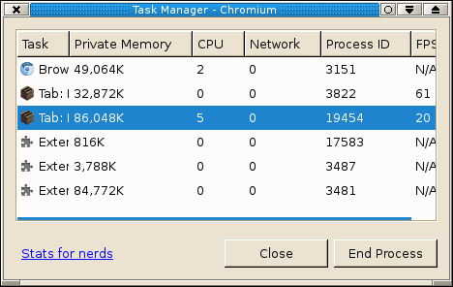
Internally, CreateJS is now drawing everything to another canvas, and then drawing that canvas to our stage when we call stage.update(). (We can obtain a reference to this internal stage via tileContainer.cacheCanvas if we want to.) The performance of this cached mode results in a great performance gain, and Chrome now reports only a few percent of its cycles used on the minesweeper mockup page.

Supplementary Listing 7. The cached Minesweeper field.
<HTML>
<head>
<title>Example 2-1: Minesweeper</title>
<script src="http://code.createjs.com/createjs-2013.05.14.min.js"></script>
</head>
<body>
<canvas id="output" width=320 height=320></canvas>
<script>
"use strict"

var stage = new createjs.Stage("output");

//Set up some z-layers, as in example 1.
var tileContainer, uiContainer;
stage.addChild(tileContainer = new createjs.Container());
stage.addChild(uiContainer = new createjs.Container());

tileContainer.cache(0,0,320,320);

//Add 1600 tiles in a square. This should load one of our processors a little, and we can observe it with our task manager. You can open one up in Chrome by pressing shift-esc.
var tiles = [];
for (var x = 0; x < 40; x++) {
tiles.push([])
for (var y = 0; y < 40; y++) {
tiles[x][y] = addTile(tileContainer, x, y);
};
};
tiles[39][39].image.onload = function() {tileContainer.updateCache()}; //When the last tile's image has loaded, we need to refresh the cache. Otherwise, we'll just draw a blank canvas.
//When we click on the tile, we should make it respond. We'll use the question mark in place of an actual game of minesweeper.
stage.addEventListener("mousedown", function revealTile(event) {
var x = Math.floor(event.stageX/8); //StageX is the pixel of the stage we clicked on. (The formula gives us the index of our tile.)
var y = Math.floor(event.stageY/8); //8 is how wide our tiles are.
tiles[x][y].image.src="images/question mark tile.png";
tiles[x][y].image.onload = function() {tileContainer.updateCache()}; //Update the cache when our new image has been drawn.
});

//Add two blue bars to the stage to track the mouse.
var horizontalBlueBar = addGridTool(uiContainer, -90);
var verticalBlueBar = addGridTool(uiContainer, 0);
//We'll make them track our mouse cursor. How quickly they do so will also give us a good feel for our framerate.
stage.addEventListener("stagemousemove", function updateGridTool(event) {
horizontalBlueBar.y = event.stageY;
verticalBlueBar.x = event.stageX;
});

//When we redraw the stage, we should make the blue bars flicker a bit for effect.
createjs.Ticker.addEventListener("tick", function paintStage() {
horizontalBlueBar.alpha = 0.3 + Math.random()/3;
verticalBlueBar.alpha = 0.3 + Math.random()/3;

stage.update();
});

function addTile(stage, x, y) {
var tile = new createjs.Bitmap("images/blank tile.png");
tile.x = x*8, tile.y = y*8; //Our tile is 16 pixels wide, but we'll scale them down for this example.
tile.scaleX = 0.5, tile.scaleY = 0.5; //We need to draw lots of objects to produce a measurable stress on a modern computer.
stage.addChild(tile);
return tile;
}

function addGridTool(stage, rotation) {
var gridTool = new createjs.Bitmap("images/bar gradient.png");
gridTool.regX = 4; //Offset the bar a bit in the narrow dimension, so our mouse will be over the middle of it.
gridTool.scaleY = 320; //Make the bar as long as the gamefield.
gridTool.rotation = rotation;
stage.addChild(gridTool)
return gridTool;
}
</script>
</body>
</HTML>

Resizing
When a canvas has its width or height properties set, it is also cleared. Without intervention, this will cause our stage to occasionally render a blank frame to screen. The graphics will be drawn by EaselJS; the canvas resized and cleared; and then the canvas will be rendered to screen by the browser. To fix this, we'll just call stage.update() after the canvas has been resized. Listing 8 has this call commented out on line 60, so you can see the difference.

Listing 8. A resizable canvas.
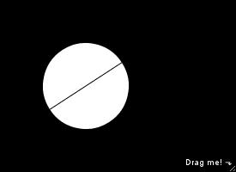
<HTML>
<head>
<title>Example 3-0: Resizing</title>
<meta charset="utf-8">
<script src="http://code.createjs.com/createjs-2013.05.14.min.js"></script>
<style>
div {
background-color: black;
overflow: hidden; /*Make the div resizable.*/
resize: both;
width: 275px;
height: 200px;
position: relative; /*Make #instructions positionable in the corner.*/
}
#output {
pointer-events: none; /*This would cover up our resizing handle otherwise.*/
width: 100%;
height: 100%;
}
#instructions {
pointer-events: none;
color: white;
font-family: Arial;
font-size: 10px;
position: absolute; /*Position the instructions in the corner with the drag handle.*/
margin: 0px;
bottom: 5px;
right: 5px;
}
</style>
</head>
<body>
<div id="container">
<p id="instructions">Drag me! ⬎</p>
<canvas id="output" width=275 height=200></canvas>
</div>
<script>
"use strict";
var stage = new createjs.Stage("output");

var circle = new createjs.Shape();
circle.graphics //Draw a circle with a line through it.
.beginFill("white")
.drawCircle(0,0,50)
.beginStroke("black")
.moveTo(-50,0)
.lineTo(+50,0)
.endStroke();
circle.x = 100;
circle.y = 100;
stage.addChild(circle);

createjs.Ticker.addEventListener("tick", function paintStage() {
circle.rotation += 1; //Rotate the circle so we can see how often we're running our logic.
stage.update();
});

function resizeStage(width, height) {
stage.canvas.width = width, stage.canvas.height = height;
//stage.update();
};

//Watch for our parent container getting resized. (There is no native event for this.)
var element = document.getElementById("container");
window.addEventListener("mousemove", function pollSize(event) { //We'll watch for the mouse being moved, and check if the mouse is resizing the container.
var newWidth = parseInt(element.style.width) || stage.canvas.width; //Style.width and style.height aren't set until we resize the container in that direction, so we might legitimately have to resize x to something while y is undefined.
var newHeight = parseInt(element.style.height) || stage.canvas.height;
if(newWidth !== stage.canvas.width || newHeight !== stage.canvas.height) {
resizeStage(newWidth, newHeight); };
});

stage.update();
</script>
</body>
</HTML>

CreateJS encourages separation of logic and rendering, so we can simply tell it to draw the stage twice a “frame”. This is also useful on mobile devices, where the user can rotate the phone. It is not nice to have the entire screen flicker if you've got a full-screen canvas displayed. The solution really is simple, but it had eluded me for a long time.

Side note: There is no onresize function for HTML elements, even ones marked as resizable in CSS! In the solution here, I have sacrificed some speed and correctness for simplicity.

HTML5 and CreateJS
Because a CreateJS stage is a simple wrapper around a canvas tag, stages behaves like “just another element”. It can be styled with CSS, animated via jQuery, transformed, and flowed with the rest of the page content. If you were making a game with CreateJS, you would probably want to design the majority of your user interface in HTML and layer it on top of the game. In the following example, we will make the player character, Frogatto, ask for some input.

Listing 9: HTML Input
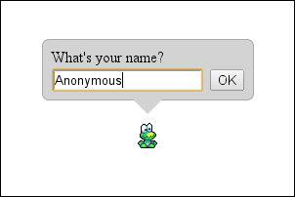
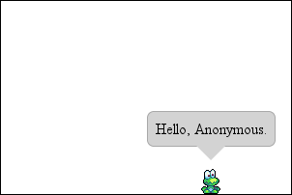
<HTML>
<head>
<title>Example 4-0: DOM Interface</title>
<meta charset="utf-8">
<script src="http://code.createjs.com/createjs-2013.05.14.min.js"></script>
<style>
#speech-bubble { /*A grey speech-bubble.*/
background-color: lightgrey;
position: absolute; /*Make bubble repositionable.*/
display: inline-block;
border-radius: 7.5px;
padding: 7.5px;
margin-left: 0px; /*These will get set from the Javascript.*/
margin-top: 0px;
border: 1px solid darkgrey;
}
#speech-bubble:after { /*Give the speech bubble a triangular point.*/
content: "";
position: absolute;
left: 50%; /*Center the triagle.*/
margin-left: -15px; /*Give the triangle a negative margin of half the triangle width, so the triangle is centered.*/
bottom: -15px; /*Make a triangle 15px high and offset it downwards by that much.*/
border-width: 15px 15px 0;
border-style: solid;
border-color: lightgrey transparent;
}
canvas {
outline: 1px solid black;
cursor: move;
}
</style>
</head>
<body>
<div id="speech-bubble">
What's your name?<br>
<input id="name" onkeypress="if(event.which === 13) getName()"></input> <button onclick="getName()">OK</button>
</div>
<canvas id="output" width=300 height=200></canvas>
<script>
"use strict";
var stage = new createjs.Stage("output");
createjs.Ticker.addEventListener("tick", function paintStage() {
stage.update(); });

//Create a new player. He's draggable with the mouse.
var playerSpriteSheet = new createjs.SpriteSheet({
images: ["images/frogatto.png"], //A simplified edition of Frogatto, from Frogatto & Friends. Used with permission.
frames: [
//[x, y, width, height, imageIndex, regX, regY]
[124,18,32,32,0,16,31], //Idle animation.
[159,18,32,32,0,16,31],
[194,18,32,32,0,16,31],
],
animations: { //Refer to http://www.createjs.com/Docs/EaselJS/classes/SpriteSheet.html for documentation.
idle: { //We will use an idle animation for this example, to give it some life.
frames:[0,1,2,1],
frequency: 6,
next: "idle",
},
}
});

var player = new createjs.BitmapAnimation(playerSpriteSheet);
player.gotoAndPlay('idle');
player.x = 150, player.y = 150;
stage.addChild(player);

player.onPress = function(event) {
var offset = { //Capture the offset of the mouse click relative to the player.
x: event.target.x - event.stageX,
y: event.target.y - event.stageY,
};
event.onMouseMove = function(event) { //During this click, when we move the mouse, update the player position and the speech bubble position.
event.target.x = event.stageX + offset.x;
event.target.y = event.stageY + offset.y;
repositionSpeechBubble(event.target);
stage.update(); //Update the stage early to synch with user input better. This does make the player animation play faster, however.
}
}

//Position the speech bubble HTML element above
var speechBubble = document.getElementById("speech-bubble");

function calculateSpeechBubbleOffset() { //We don't have access (that I know about) from CSS to calculate 'half our width' as a margin value. This is essentially a regX/regY value for the DOM speech bubble, which makes later positioning easier and faster.
speechBubble.style.marginLeft = -speechBubble.offsetWidth/2+"px";
speechBubble.style.marginTop = -speechBubble.offsetHeight+"px";
}
calculateSpeechBubbleOffset();

function repositionSpeechBubble(object) {
object = player.localToGlobal(8,-40); //The offset of the speech bubble point from our regX/regY point.
speechBubble.style.left = object.x + 'px',
speechBubble.style.top = object.y + 'px';
}
repositionSpeechBubble(player);

function getName() {
var name = document.getElementById("name").value;
document.getElementById("speech-bubble").innerHTML = "Hello, "+name+".";
calculateSpeechBubbleOffset();
}
</script>
</body>
</HTML>

We can drag Frogatto around, and the text box moves with him.

Drawing a text input box would be time-consuming using CreateJS, since we'd have to figure out how to draw: a box; text; a cursor; text selection, an ok button; and then how to position it all. Since we have the power and depth of HTML available to us, we should use it where we can!

This also helps with “separation of duty” in code. We can style our text boxes without having to figure out the program first. We don't have to parse all the style details of our text boxes when we're figuring out how the program positions them over Frogatto.

In closing, I would recommend using CreateJS if you want to draw animations on a web page. As with the majority of Javascript libraries, it's most useful in conjunction with the rest of HTML5. CreateJS is a powerful abstraction, although it can introduce significant overhead if misused.

